Ammar Ahmed BDS2B2
20L-0961

Lab 11 Tasks
Task 1
SR Master-Slave flip flop:

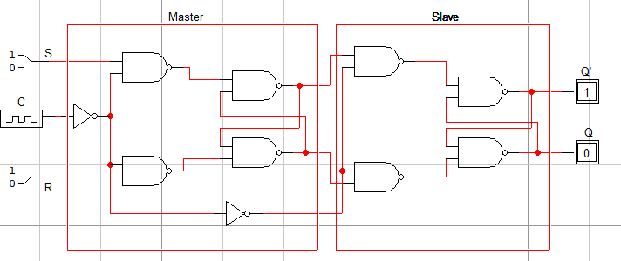
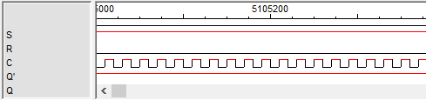

Task 2
D-Flip Flop & JK Flip Flop
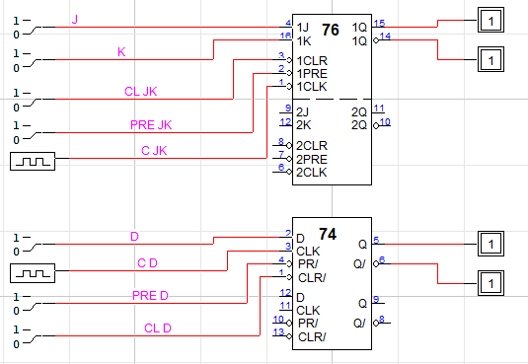
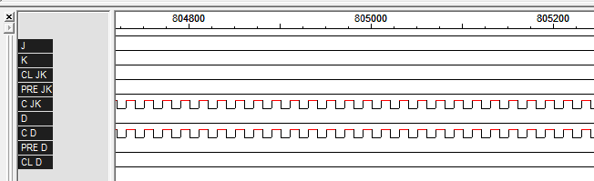

Task 3
Master Slave FF, using the JK FF IC
